Electrons and the Three Basic Actions
  - Prologue 5 of Quantum, Actually, Volume 2: A QED Course
Lothar J. Musiol

Electrons have arrows too. Everything in this course, at this level, is built from three actions: a photon goes from place to place, an electron goes from place to place, an electron emits or absorbs a photon

First edition, 2026

How to use this prologue
Prologues 1–4 were about light alone. Glass, mirrors and lenses entered as given objects: "the surface reflects 4 percent". Now we look inside them. The surprise is how little is needed: electrons, photons, and three things they can do. Feynman's view was that, apart from gravity and radioactivity and the nucleus, everything in physics and chemistry follows from these three actions; this course will spend Lessons 39–79 making that statement exact. Here it is said with arrows and pictures only. Expect three hours.

Learning objectives
- Explain why electrons, like photons, must be described by arrows.
- Read and draw a space-time diagram: position across, time up.
- Name the three basic actions and say what kind of arrow each one contributes.
- Build the arrow for two electrons scattering off each other by exchanging a photon, and say why more complicated exchanges are smaller.
- Explain partial reflection from glass in terms of electrons absorbing and re-emitting photons.
- Read a line running backwards in time as a positron, and explain what a Feynman diagram is and is not.

Words you will need
Word | What it means here
space-time diagram | A drawing with position across the page and time up the page
point | A place at a moment: "here, at 3 o'clock"
junction | The point where an electron emits or absorbs a photon
j | The junction number: about −0.1 (shrink to a tenth, reverse)
exchange | One electron emits a photon that another absorbs
positron | The antiparticle of the electron: same mass, opposite charge

1 Electrons have arrows too
Send electrons, one at a time, at a screen with two narrow slits, and record where each arrives on a detector behind. Each electron arrives at one spot, like a click. But after many electrons, the spots form bands — bright and dark stripes — exactly like light through two slits. With one slit closed, the bands disappear. Put a detector at the slits that records which slit each electron went through, and the bands disappear again (Prologue 1, Section 5).
So electrons obey the same rule as photons: one arrow per way, add the arrows, square. What differs is how the arrow for an electron's journey is worked out. That is where the three actions come in.

2 Pictures with time going up
To keep track of where and when things happen, draw a space-time diagram: position across the page, time up the page. A particle sitting still is a vertical line. A particle moving to the right is a line slanting to the right. Light is the fastest thing there is; choose units so that it moves one square across for one square up, and a photon is a line at 45°.
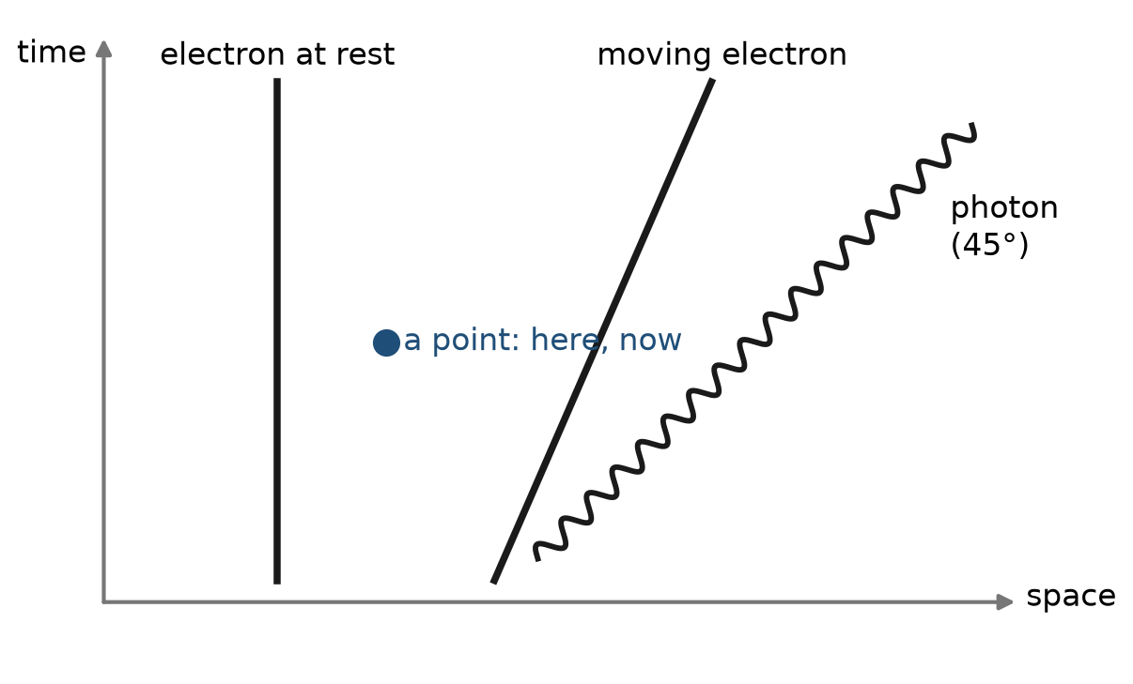
Figure P5.1. A space-time diagram. An electron at rest is a vertical line; a moving electron leans over; a photon runs at 45 degrees. Each point on the diagram is a place at a moment.

3 The three basic actions
Action 1: a photon goes from one point to another. Its arrow depends on how far apart the two points are in space and in time. The arrow is large when the photon would have to travel at exactly the speed of light, and small otherwise — though, strangely, not exactly zero. Over distances of more than a few wavelengths, the contributions from "slightly faster or slower than light" cancel, and light behaves as if it always travelled at exactly c.
Action 2: an electron goes from one point to another. Its arrow, too, depends on the separation in space and time. It is more complicated than the photon's, because the electron has mass and can travel at any speed below c; for now we only need to know that such an arrow exists and can be calculated (Lesson 47 gives the formula).
Action 3: an electron emits or absorbs a photon. This happens at a single point, a junction. It contributes a fixed number, called here j: an arrow of length about 0.1, reversed. (More precisely, about 0.085.) Its square, j², is about 1/137. That number, 1/137, is the famous fine-structure constant α — the strength of electricity and magnetism. Every time a picture contains one more junction, the arrow for it is shrunk by another factor of about 0.1.
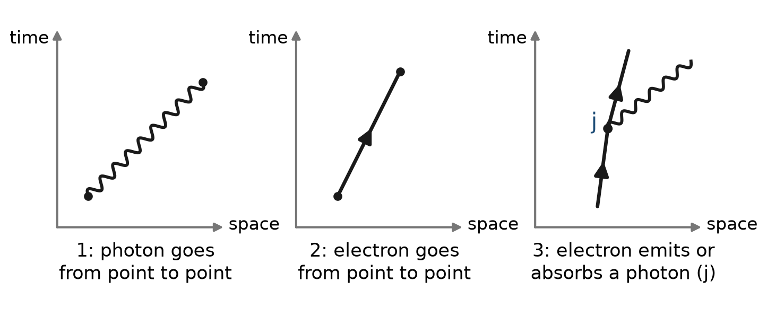
Figure P5.2. The three basic actions. A photon goes from point to point (wavy line). An electron goes from point to point (straight line with arrowhead). An electron emits or absorbs a photon at a junction (dot), contributing the factor j.
That is the complete list. Every process involving light and electrons is made of these three pieces joined together in every possible way.
Try it now 1
A picture has four junctions. By roughly what factor is its arrow shrunk, compared with a picture with no junctions? By what factor is its probability shrunk?

4 Two electrons meet
Two electrons start at points 1 and 2 and later turn up at points 3 and 4. What is the arrow for that?
The simplest way. Electron 1 goes to 3, and electron 2 goes to 4, and nothing else happens. Its arrow is E(1 to 3) × E(2 to 4): two Action-2 arrows, multiplied (shrink-and-turn, Prologue 4).
The next simplest way. Along the way, electron 1 emits a photon at some point 5, and electron 2 absorbs it at some point 6. Its arrow is the product of seven pieces: E(1 to 5), j, P(5 to 6), j, E(2 to 6), and then E(5 to 3) and E(6 to 4). And the points 5 and 6 could be anywhere and at any time: so add up the arrows for all possible points 5 and 6. That sum is the arrow for "exchanging one photon".
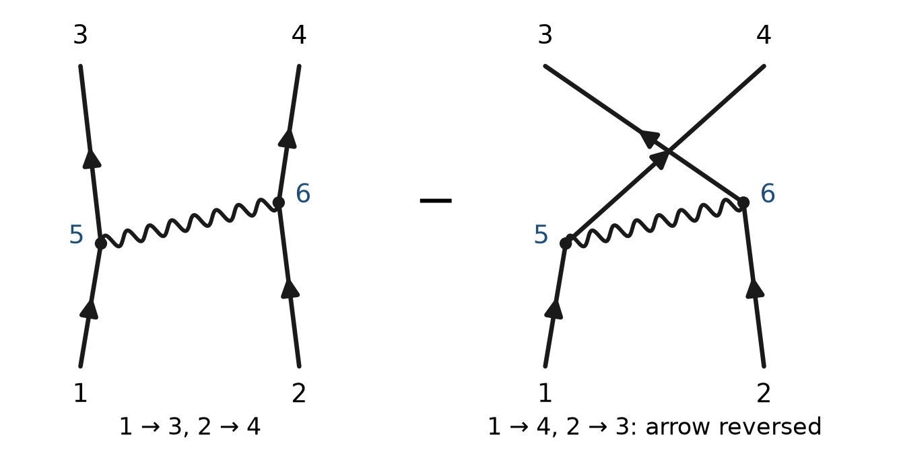
Figure P5.3. Left: two electrons exchange one photon, emitted at 5 and absorbed at 6; the points 5 and 6 can be anywhere and must be summed over. Right: the electrons are identical, so "1 ends at 4 and 2 ends at 3" is another way to reach the same result. For electrons its arrow is subtracted.
And a twist. Electrons are all identical. "Electron 1 ends at 3 and electron 2 at 4" and "electron 1 ends at 4 and electron 2 at 3" both end in the same final situation and cannot be told apart. Both pictures contribute arrows. For electrons, the second arrow is reversed before adding (for photons it is not). That single reversal is behind the Pauli exclusion principle, and with it the structure of the periodic table (Lesson 17).
Smaller and smaller corrections. Two photons could be exchanged; the electrons could emit and reabsorb photons on the way. Each such complication adds two junctions, so its arrow is smaller by about j² ≈ 1/137. That is why the simplest pictures already give most of the answer, and why the more elaborate ones are small corrections that can be added one after another (Prologue 6).
Try it now 2
Why must you add arrows for every possible position of points 5 and 6, rather than pick the most likely position?

5 Light meets an electron, and glass is explained
A photon arrives at an electron. The electron absorbs it at one point and emits a new photon at another. That is how light scatters off an electron. There is also the reverse order: the electron emits the outgoing photon first and absorbs the incoming one afterwards. Both pictures have two junctions, and both arrows are added (Lesson 57 calls these the two diagrams of Compton scattering).
Now think of a sheet of glass. It is full of atoms, and every atom has electrons. A photon heading for the glass can be scattered by any electron in any atom. Each electron contributes a tiny arrow for "scattered back towards the source". Add them all, layer by layer, through the glass. The stopwatch makes the arrow from each successive layer point in a slightly different direction, so the arrows from the inside of the glass bend round into a circle — and a circle of arrows, as you saw in Prologue 4, adds to nearly nothing. What survives is the contribution of the first and last layers: one from the front surface, one from the back.
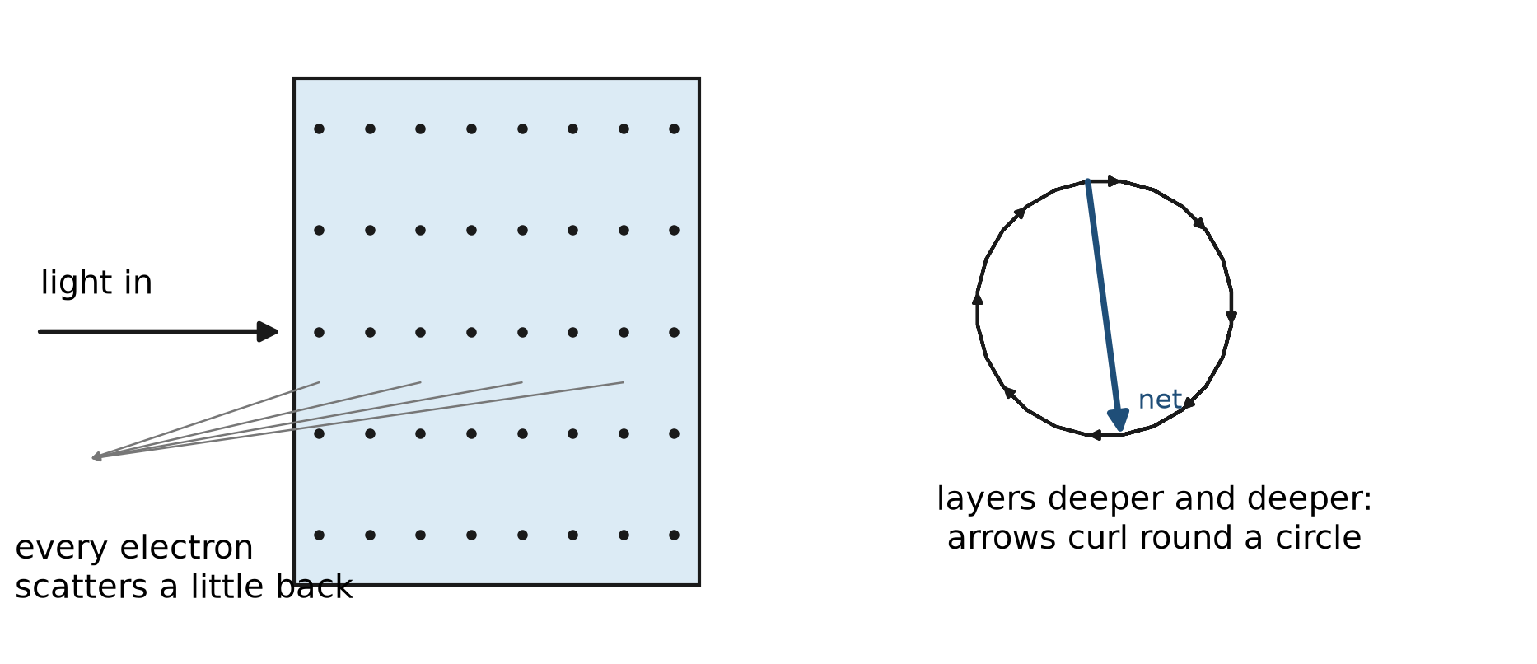
Figure P5.4. Reflection from glass, explained by electrons. Each thin layer of atoms adds a small arrow; the arrows turn steadily as the layers go deeper and curl round a circle. The total depends only on where the curling starts and stops: as if all the reflection came from the two surfaces.
So "reflection from the surfaces" is an excellent shortcut, but it is not what really happens. Reflection is the sum of scattering from every electron in the glass. The forward-going arrows from all those electrons are also what makes light travel more slowly in glass. Lesson 9 makes both statements exact.
Try it now 3
Using the picture of arrows curling round a circle: why does a very thin film (just a few layers) reflect very little? Compare with Prologue 2, Section 5.

6 Running backwards in time
Pictures made of the three actions allow something odd. An electron line can bend and run backwards in time: an electron goes forward, emits a photon, and then its line heads down the page. Feynman found that the arrow for such a line is exactly the arrow for a positron — the electron's antiparticle, with the same mass and opposite charge — travelling forward in time.
Read the zig-zag forwards in time and you see: a photon creates an electron and a positron (pair creation); later the positron meets another electron and both disappear into photons (annihilation). Positrons were predicted by Dirac in 1928 and found in cosmic rays in 1932. Hospitals use them every day in PET scanners, which detect the pairs of photons from annihilation.
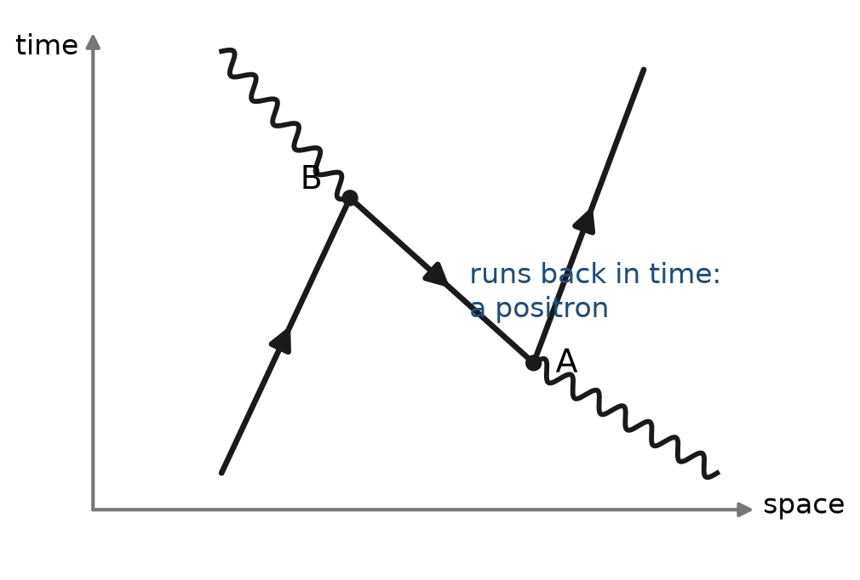
Figure P5.5. An electron line that turns back in time. Read upwards: a photon makes an electron–positron pair at A; the positron (the backward-running segment) meets the original electron at B and they annihilate into a photon.

7 What a diagram is, and what it is not
The pictures of this prologue are called Feynman diagrams. It is tempting to read them as movies: electron 1 throws a little photon, electron 2 catches it. As a reminder of which arrows to multiply, that reading is harmless. Taken literally, it misleads. The internal photon in Figure P5.3 is not a particle you could catch with a detector; it is one term in the sum that makes the arrow, and the points 5 and 6 range over every place and time, including "absorbed before it was emitted". A diagram is a recipe for one arrow. The answer is always the sum.
Two things are deliberately left out. Electrons spin, and photons are polarised; both make the arrows richer, and Lessons 15, 20–22 and 38 add them. The rules here are enough to see the structure of the whole theory.

Connections to QED
Idea in this prologue | Where it becomes exact
Action 1: photon goes from point to point | The photon propagator, Lesson 48
Action 2: electron goes from point to point | The electron propagator, Lesson 47
Action 3: junction number j | The vertex ieγ^{μ}, Lesson 45; j² ↔ α = e²/4π ≈ 1/137
Sum over the points 5 and 6 | Integration over vertex positions; momentum conservation, Lesson 53
Reversed arrow for swapped electrons | Fermi statistics, Lessons 17 and 37; the relative minus sign in Lesson 55
Backward-running electron = positron | Antiparticles, Lesson 23; the crossing of diagrams, Lessons 56–58
Glass from electrons | Lesson 9 (forward scattering and the refractive index)

Summary
- Electrons interfere: they have arrows, combined by the same rule as photons.
- A space-time diagram has position across and time up; a photon runs at 45°.
- Three basic actions: a photon goes from point to point; an electron goes from point to point; an electron emits or absorbs a photon, contributing j ≈ −0.1 (j² ≈ 1/137).
- Two electrons scatter by exchanging photons; every place and time for the junctions is summed, and swapping identical electrons gives a reversed arrow.
- Each extra pair of junctions makes a picture smaller by about 1/137, so simple pictures dominate.
- Reflection from glass is the sum of scattering from every electron in it; only the surfaces fail to cancel.
- An electron running backwards in time is a positron. A diagram is a recipe for one arrow, not a movie.

Exercises
No | Problem
1 | Core. Draw a space-time diagram showing an electron at rest, a photon sent to the right from the electron at time 0, and a second electron at rest 3 squares to the right that absorbs it. At what time is it absorbed?
2 | Core. List the pieces (which actions, and how many junctions) in the arrow for "an electron absorbs a photon and later emits another".
3 | Core. A picture with 2 junctions has an arrow of length about 0.01 times some other factors. Roughly how much smaller is the arrow for a picture of the same process with 4 junctions?
4 | Core. Why does the light inside a sheet of glass not reflect, even though it meets electrons all the way through?
5 | Core. In your own words, why is a Feynman diagram not a movie of what happened?
6 | Extension. Two identical electrons have equal arrows for "1 to 3, 2 to 4" and "1 to 4, 2 to 3". What is the probability that they end up at 3 and 4? What does that say about two electrons in the same state?
7 | Extension. j² is about 1/137. What is j to two significant figures?
8 | Extension. Draw the two diagrams for a photon scattering off an electron (absorb first, or emit first), labelling the junctions.
9 | Challenge. Explain why a photon's arrow for travelling slightly faster than light does not lead to signals sent faster than light over everyday distances.
10 | Challenge. Draw a single diagram, built only from the three actions, in which two photons come in and two photons go out. How many junctions does it have, and why is this process extremely rare for visible light?

Solutions
Try each exercise on paper before you look. If you are stuck, re-read the section named in the exercise, try again, and only then read the solution below.
1. Both electrons are vertical lines, 3 squares apart. The photon starts at (0, 0) and runs at 45°: it reaches the second electron at time 3 (three squares up).
2. Action 1 (the incoming photon arrives), Action 2 (the electron goes to the absorption point), Action 3 (absorption: j), Action 2 (the electron goes on to the emission point), Action 3 (emission: j), Action 1 (the outgoing photon leaves), Action 2 (the electron goes on). Two junctions, so a factor j².
3. Two more junctions: smaller by about j² ≈ 1/137, so roughly 0.01/137 ≈ 0.00007 times the same other factors.
4. Every electron does scatter a little light backwards, but the arrows from successive layers turn steadily and curl round in circles that add to nearly zero. Only the start and end of the curling, the surfaces, leave a net arrow.
5. The internal photon is not detected, and the junction points range over all places and times, including impossible-looking orderings. The diagram stands for one term in a sum; only the sum, squared, predicts what is observed.
6. The second arrow is reversed before adding: equal arrows minus each other give zero. The probability is zero. Two electrons cannot be found in exactly the same state: this is the Pauli exclusion principle.
7. √(1/137) ≈ 0.085, so j ≈ −0.085 (with the reversal), "about −0.1".
8. Diagram A: incoming photon meets the electron line at junction 1 (absorbed); higher up, at junction 2, the outgoing photon leaves. Diagram B: the outgoing photon leaves at the lower junction and the incoming photon is absorbed at the upper one. Each has two junctions; the arrows are added.
9. The off-speed contributions point in rapidly varying directions as the distance grows, so they cancel among themselves except within a few wavelengths of the source. Nothing usable can be sent with them; what arrives at a distant detector behaves as light at exactly c. (Lesson 46 shows the same statement as the behaviour of the propagator outside the light cone.)
10. The photons cannot meet directly — there is no photon-photon action — so an electron must mediate: a closed electron loop with four junctions, one for each photon. Four junctions give a factor j⁴ ≈ (1/137)², about 1/19 000 in the arrow and its square far smaller still; on top of that, for visible light the loop's arrow is suppressed further because the photon energy is tiny compared with the electron's mass. Light-by-light scattering was first seen in 2017, using the intense photon fields around lead nuclei colliding at the Large Hadron Collider.

Answers to Try it now
1. Each junction shrinks the arrow by about 0.1, so four give about 0.1⁴ = 0.0001. The probability, the square, shrinks by about 10⁻⁸.
2. You cannot tell where the photon was emitted or absorbed; all positions are ways that end in the same final situation, so every one contributes an arrow, and they must all be added. Picking one position would ignore the cancellations and reinforcements between them.
3. With only a few layers there is only a tiny piece of the circle: the arrows from the front and back of the film almost cancel, just as the reversed front arrow and the back arrow did in Prologue 2.

Next lesson
Prologue 6 looks at what the three actions predict when they are combined in more elaborate ways — the electron's magnetism, measured to twelve digits — and at what physicists still do not understand.

